Task 7 :- 1) Update 2)Alter 3)Delete on view table

1. UPDATE :-

Update is not performing in view

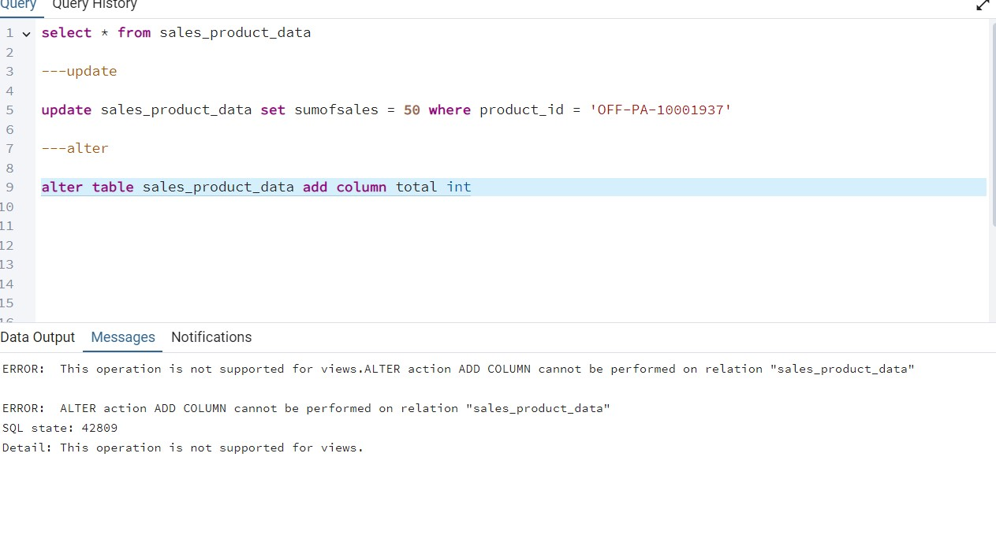

2)ALTER :-

Error when we adding a column

-------

-----RENAME COLUMN :-

Successfully run rename querry.



3)DELETE :-

Delete is not run on the view table.

